**Shane Steven S. Martos**

**BSIT, ITS, CCST**

E-mail Address: stevenmartos123@gmail.com

Credly Account: [www.credly.com/users/shane-steven-martos](http://www.credly.com/users/shane-steven-martos)

Portfolio: <https://shanemartos12.github.io/S/>

# Career Objective

Enthusiastic IT student with a strong foundation in programming, tech support, cybersecurity, coding, and web development. A fast learner committed to acquiring new skills and staying abreast of emerging technologies. Seeking a challenging career opportunity to leverage my diverse skill set and passion for technology, contributing to a dynamic team while continuously expanding my knowledge in the ever-evolving IT landscape.

# Personal Information

Birthdate: March 12, 2002

Place of Birth: Quezon City

Religion: Catholic

Status: Single

# Educational Background

**Guagua National Colleges** Rep. Eligio Lagman St, Sta. Filomena Rd, Guagua, Pampanga

➔ **Bachelor of Science in Information Technology (BSIT)** 2020 - Present



**Mary The Queen College of Pampanga** San Matias, Guagua Pampanga

➔**Humanities and Social Sciences (HUMSS)** 2018- 2020

**Professional Licenses/Certifications**

**IT Certifications:**



**Information Technology Specialist (ITS)**

## 

**Cisco Certified Support Technician Cybersecurity**

**Non-Accredited Certifications:**



## Google Data Analytics Certificate

March 2023



## Google IT Support Certificate

April 2023



## Google Project Management Certificate

November 2022



## Google Digital Marketing & E-commerce Certificate

December 2022

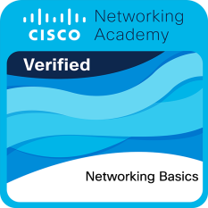

## Networking Basics Certificate

Date issued: March 2023



## Computer Hardware Basics Certificate

Date issued: February 2023

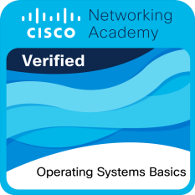

## Operating System Basics Certificate

Date issued: February 2023

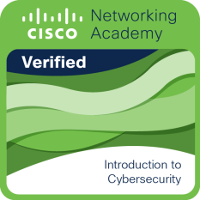

## Introduction to Cybersecurity Certificate

Date issued: February 2023



## Introduction to Internet of Things Certificate

Date issued: February 2023

**Personal Works / Capstone Project**

**Web Development:**

* Rock, Paper, Scissors -<https://shanemartos12.github.io/R-S-P/>
* Portfolio - <https://shanemartos12.github.io/S/>
* Hairday - <https://shanemartos12.github.io/hairday12/>
* Interface - <https://shanemartos12.github.io/changer/>
* Tindogs - <https://shanemartos12.github.io/tindogs/>

* Java Script
* PHP
* HTML
* CSS
* Bootstrap
* Basic Network Configuration

I hereby certify that the above information is true and correct to the best of my knowledge and belief.

Shane Steven S. Martos

applicant